Assignment

Lab 10 – Code Review and Quality

Task 1 – Syntax and Logic Errors

Original Code:
def calc_average(marks):
total = 0
for m in marks:
total += m
average = total / len(marks)
return avrage
marks = [85, 90, 78, 92]
print("Average Score is ", calc_average(marks)
Issues Identified:
- Improper indentation.
- Typo in variable name 'avrage'.
- Missing closing parenthesis in print statement.
- No input validation (possible ZeroDivisionError).
- No docstring or type hints.
Fixed Code + Output:
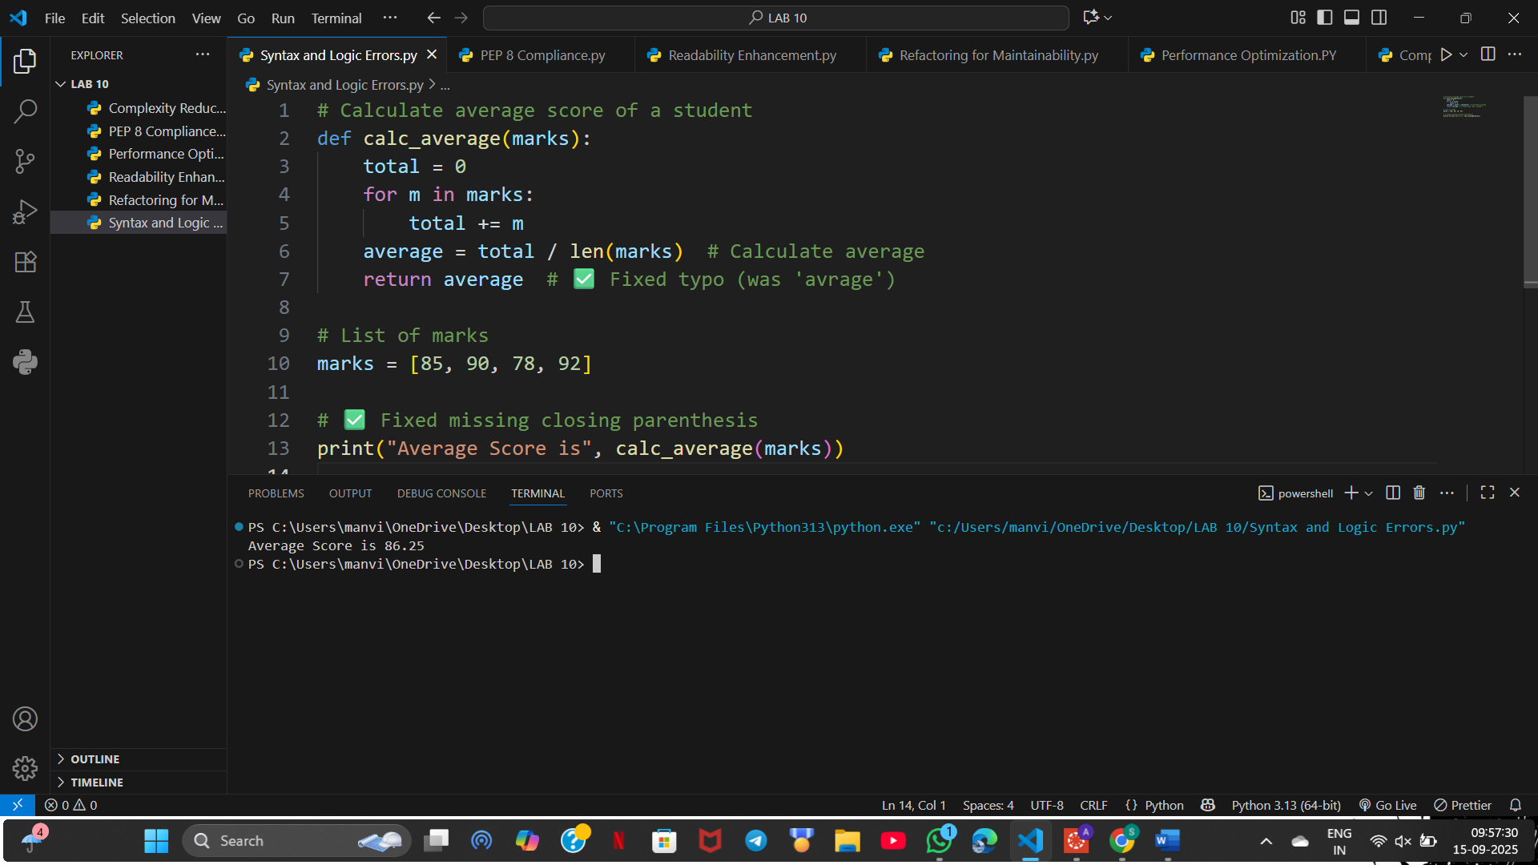

Task 2 – PEP 8 Compliance

Original Code:
def area_of_rect(L,B):return L*B
print(area_of_rect(10,20))
Issues Identified:
- Function parameters use uppercase letters (should be lowercase and descriptive).
- One-liner function reduces readability.
- Missing docstring and type hints.
- No space after commas.
Refactored Code + Output:
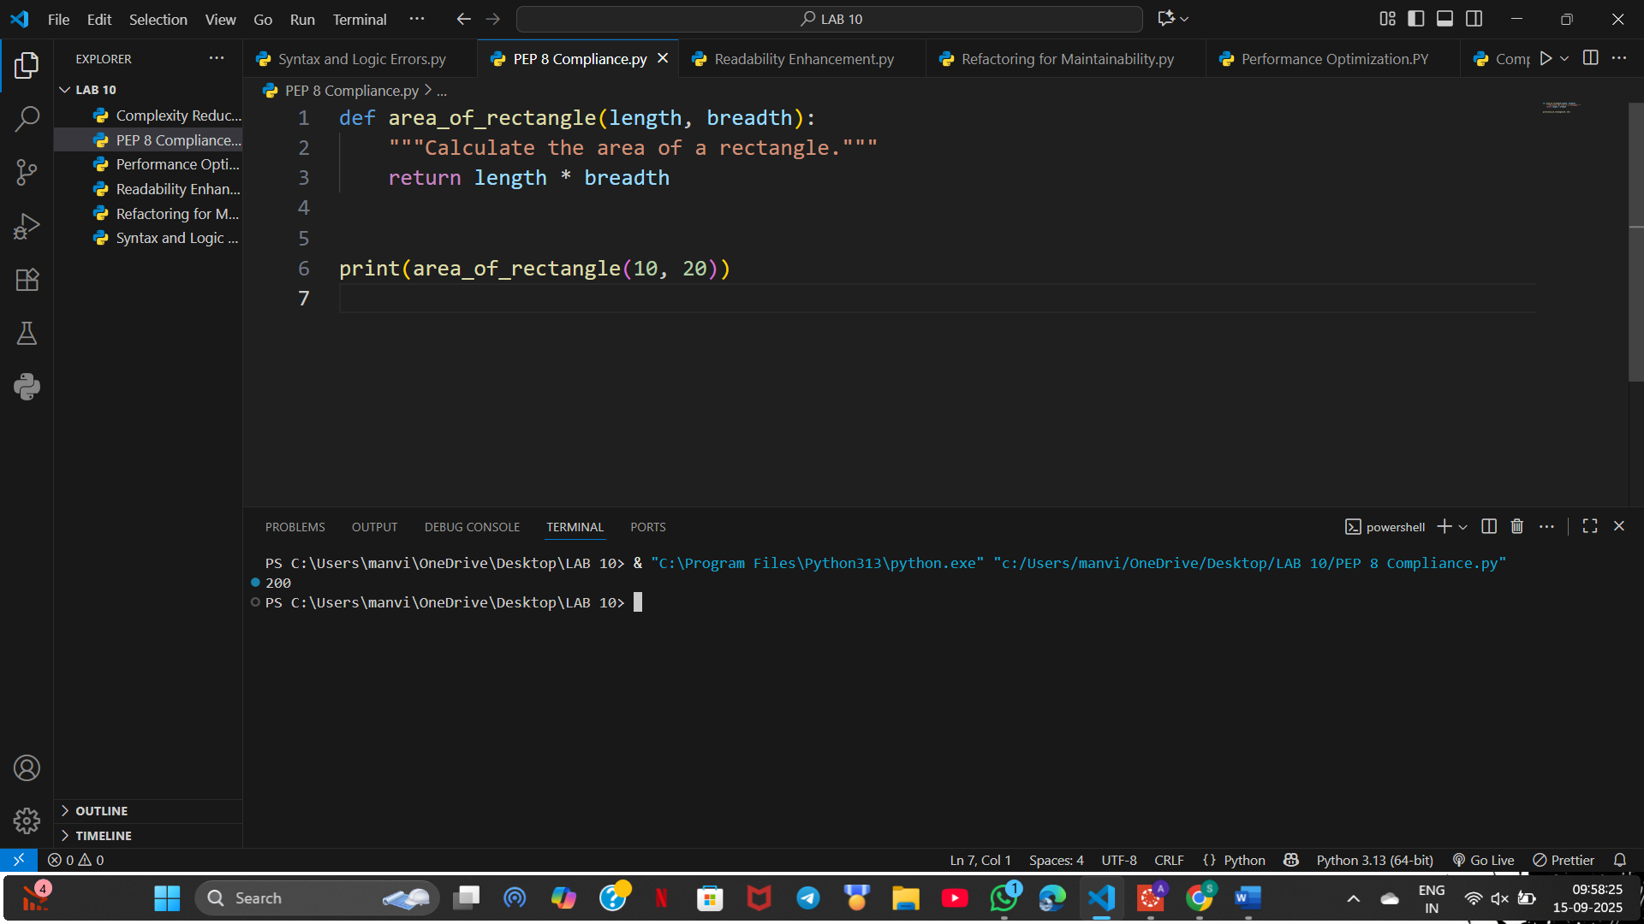

Task 3 – Readability Enhancement

Original Code:
def c(x,y):
return x*y/100
a=200
b=15
print(c(a,b))
Issues Identified:
- Non-descriptive function name ('c').
- Non-descriptive variable names ('a', 'b').
- No docstring or inline comments.
- Missing indentation and poor formatting.
Refactored Code:
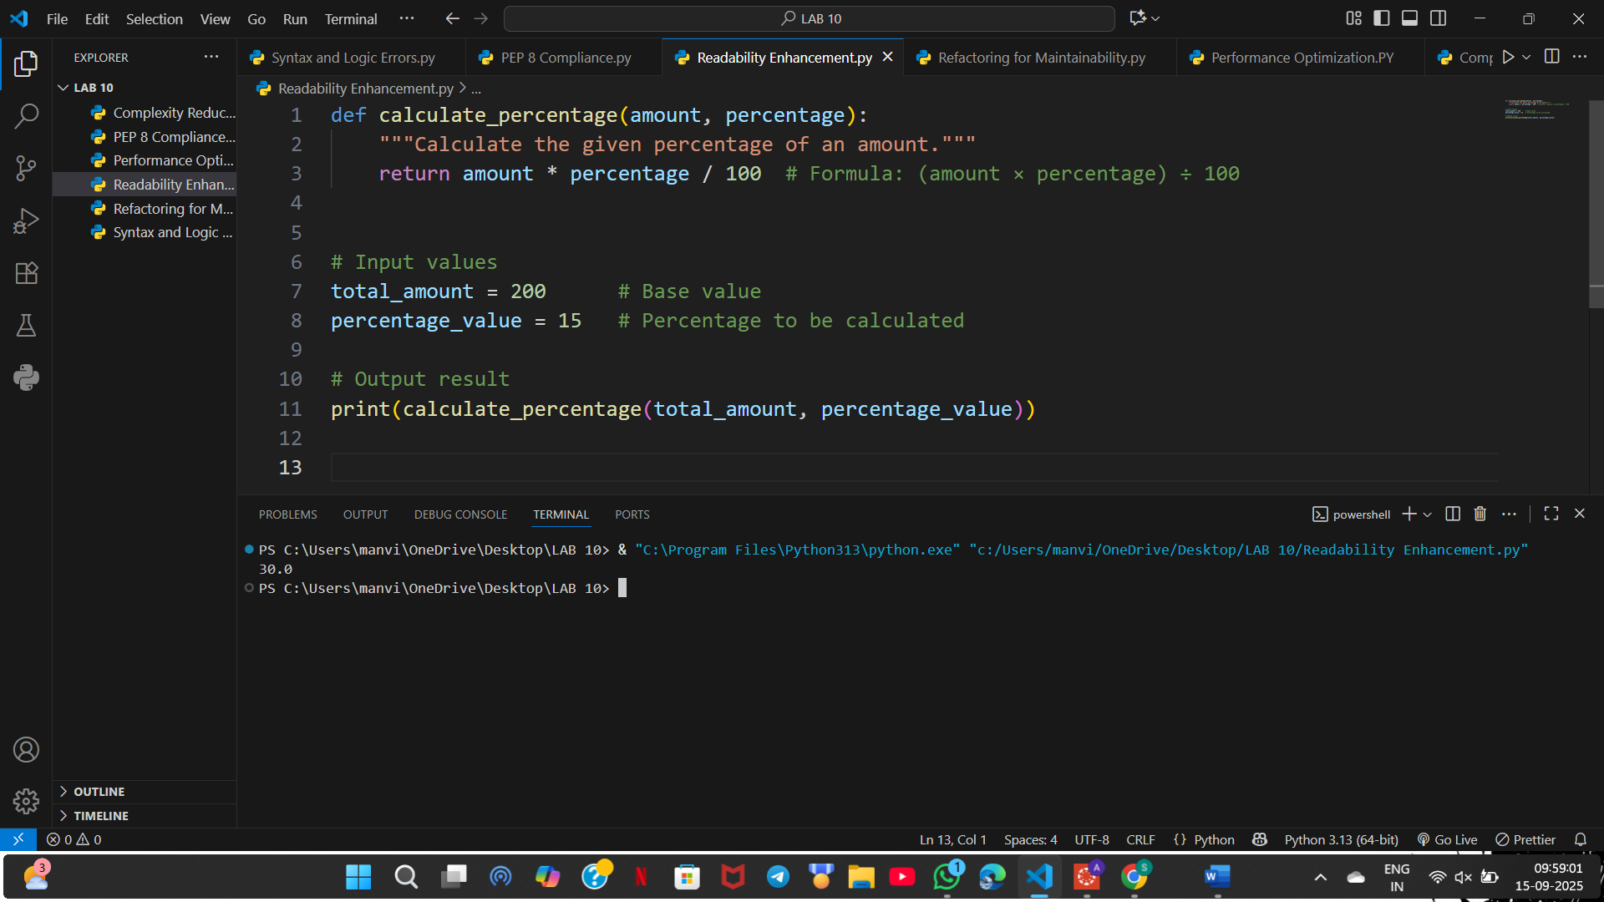

Task 4 – Refactoring for Maintainability

Original Code:
students = ["Sai", "Manvith", "Vishwas", "Vinith", "Snehal"]
print("Welcome", students[0])
print("Welcome", students[1])
print("Welcome", students[2])
Issues Identified:
- Repeated print statements (not scalable).
- No modularity, cannot handle larger student lists.
- No function abstraction.
- Harder to maintain and reuse.
Refactored Code + Output:
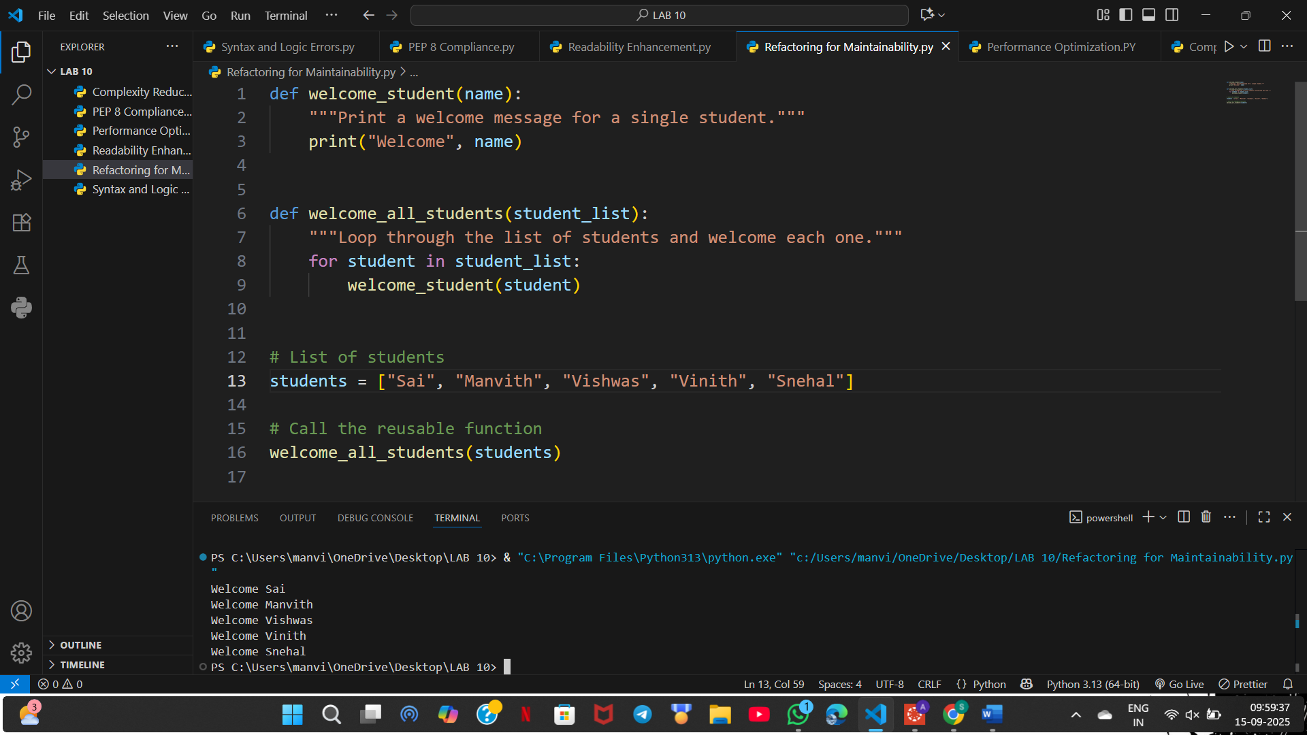

Task 5 – Performance Optimization

Original Code:
nums = [i for i in range(1,1000000)]
squares = []
for n in nums:
squares.append(n**2)
print(len(squares))
Issues Identified:
- Inefficient loop with append (slower than list comprehension).
- Creates unnecessary intermediate list 'nums'.
- High memory usage for large ranges.
- Not scalable.
Refactored Code + Output:

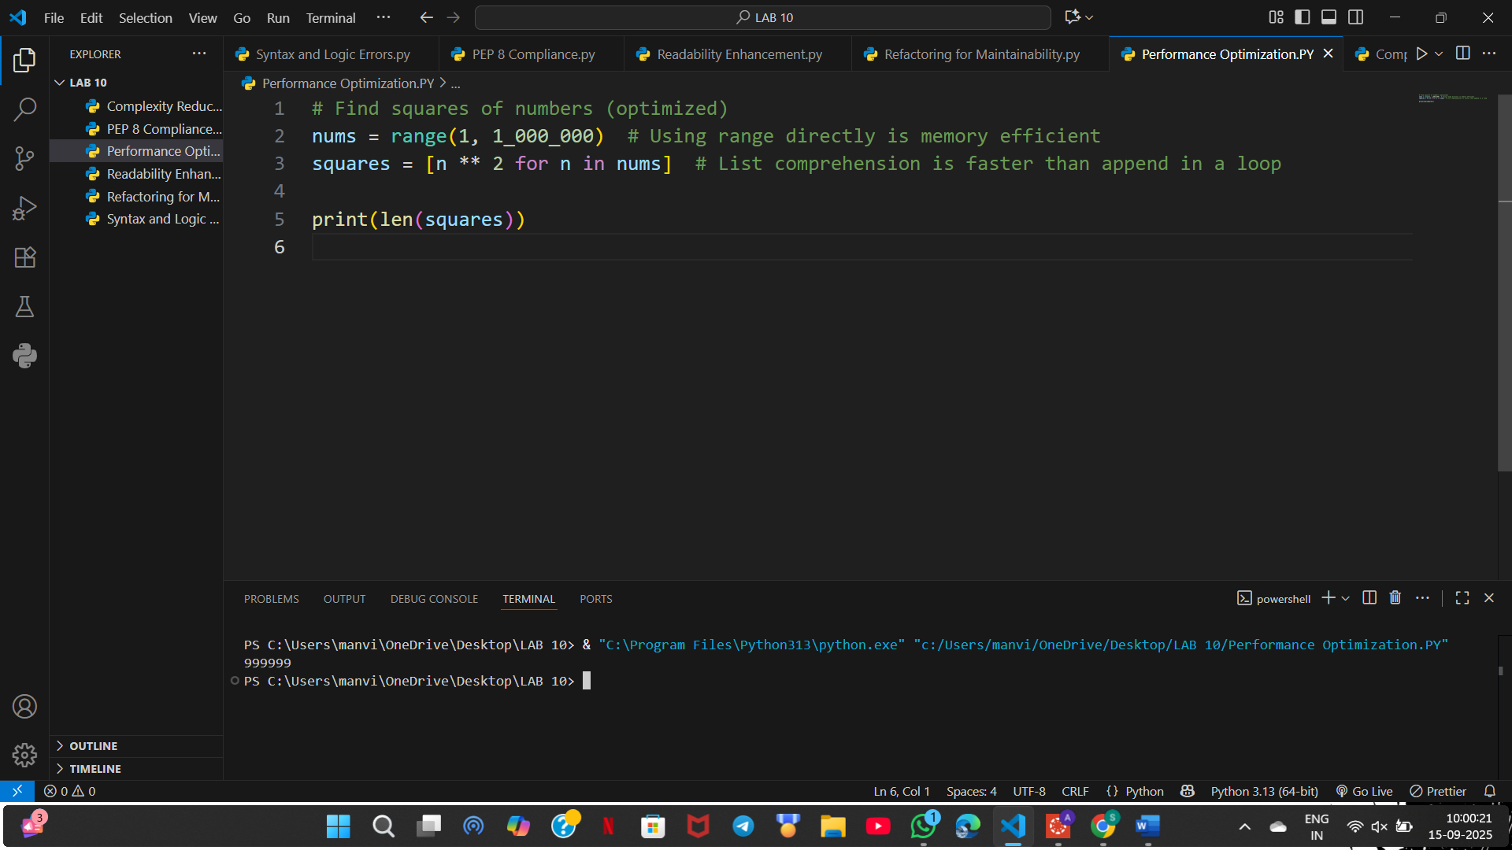

Task 6 – Complexity Reduction

Original Code:
def grade(score):
if score >= 90:
return "A"
else:
if score >= 80:
return "B"
else:
if score >= 70:
return "C"
else:
if score >= 60:
return "D"
else:
return "F"
Issues Identified:
- Overly nested if-else statements (hard to read).
- Poor maintainability.
- No type hints or docstring.

Refactored Code with elif + Output:
